Practical :- 1

- Cmd Commands

- Ping :-
- Ping command is used to check whether a computer or network device is reachable or not.
- It sends small data packets (ICMP Echo Request) to a target IP address or website and waits for a reply.
- Ping also helps measure network delay (latency) and packet loss.
Example:-
Command :- Ping facebook.com
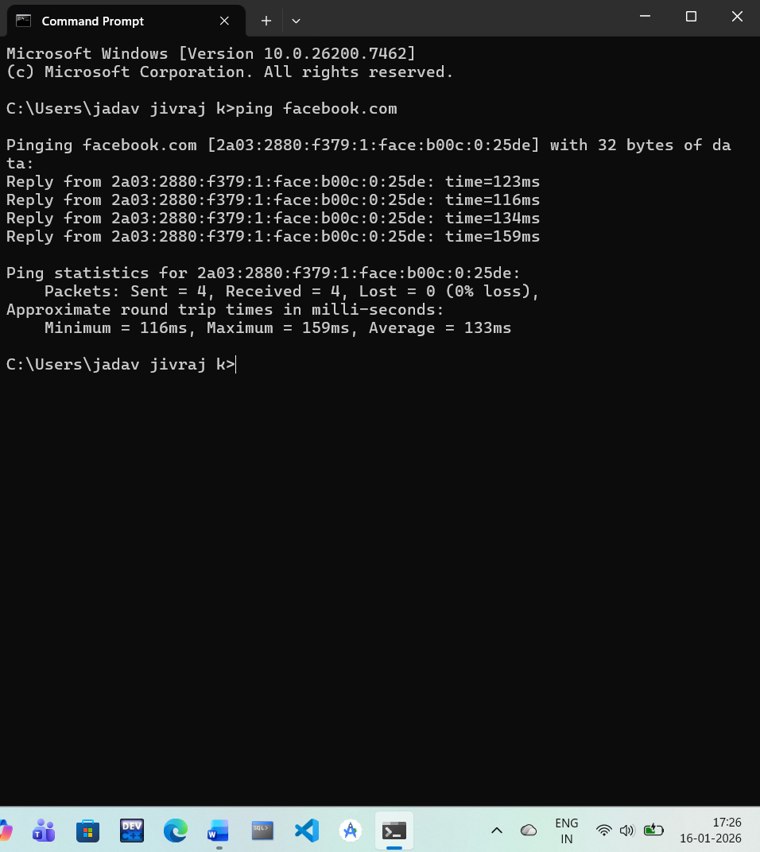
- IPConfig :-
- ipconfig is a Windows command used to display the network configuration of your computer.
- It shows details like IP address, subnet mask, default gateway, and network adapter information.
- The ipconfig command is helpful for troubleshooting network and internet connectivity issues.
Example:-
Command:- Ipconfig
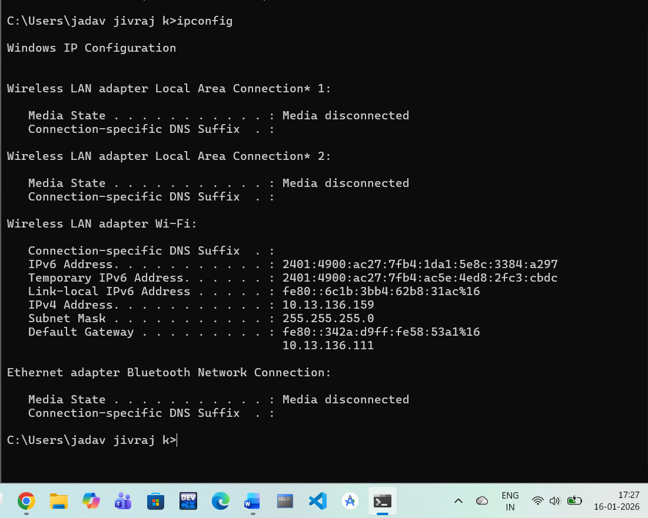

- Tracert :-
- tracert (Trace Route) is a Windows command used to show the path that data packets take to reach a destination.
- It lists all the routers (hops) between your computer and the target IP address or website.
- The tracert command helps identify where network delays or connection problems occur.
Example:-
Command :- tracert facebook.com
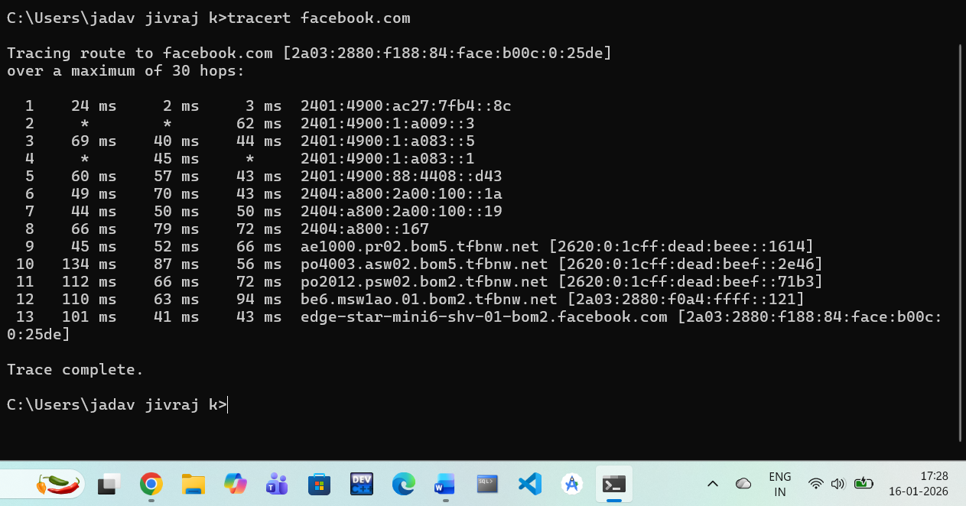

- ARP :-
- arp (Address Resolution Protocol) is a command used to view and manage the ARP cache in a computer.
- It shows the mapping between IP addresses and their physical (MAC) addresses on a local network.
- The arp command is mainly used for network troubleshooting and monitoring local devices.

Example:-
Command :- Arp
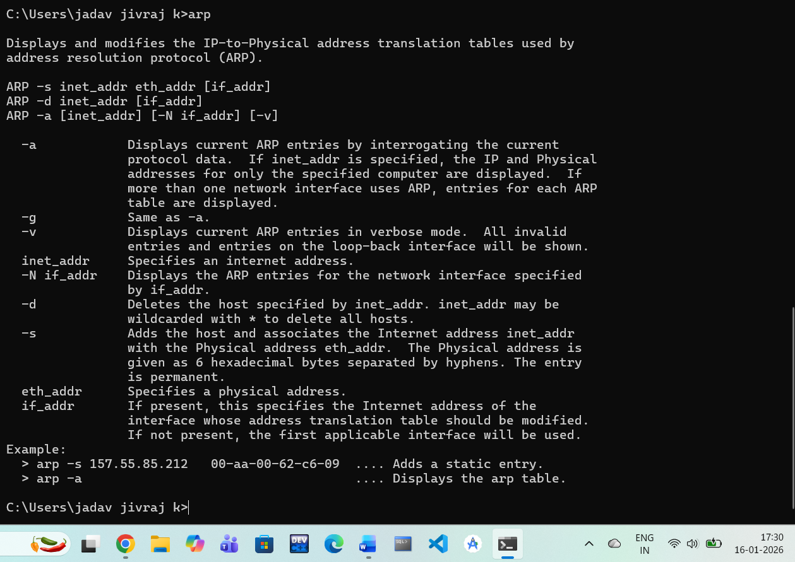

- tcpdump :-

- tcpdump is a network packet-capturing command used to monitor and analyze network traffic in real time.
- It captures data packets passing through a network interface and displays details like source, destination, and protocol.
- Tcpdump is mainly used for network troubleshooting and security analysis on Unix/Linux systems.

Example:-
Command :- Tcpdump -i eth0

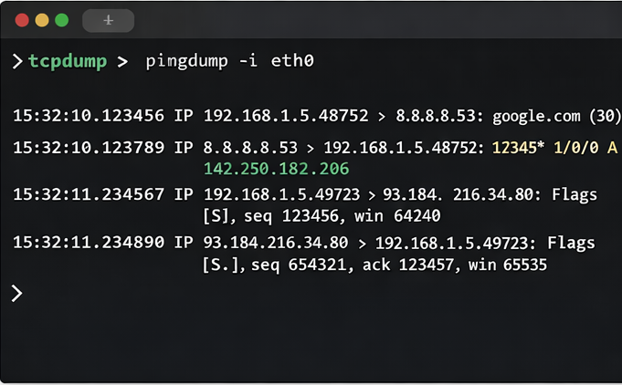

- Whois :-
- whois is a command used to get registration details of a domain name or IP address.
- It provides information such as domain owner, registrar, registration date, and expiry date.
- The whois command is useful for network administration and cybersecurity investigations.

Example :-
Command :- Whois google.com
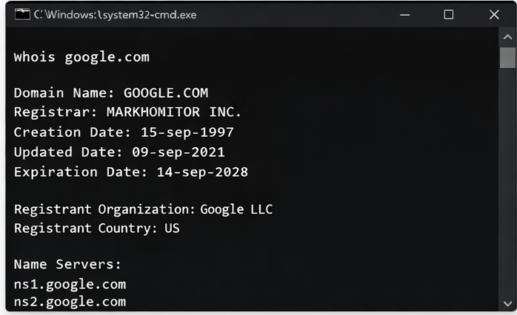
- Host :-
- host is a DNS lookup command used to find the IP address associated with a domain name.
- It can also display mail servers (MX records) and other DNS records of a domain.
- The host command is commonly used for DNS troubleshooting and verification.
Example :-
Command :- host google.com
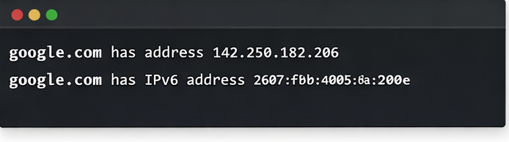

- Telnet :-
- telnet is a command used to remotely connect to another computer over a network using the Telnet protocol.
- It allows users to communicate with a remote system through a text-based interface.
- The telnet command is mainly used for testing network services, but it is not secure because data is sent in plain text.
Example :-
Command :- smpt.example.com 25
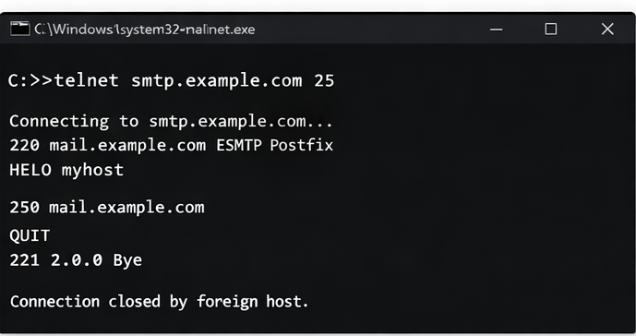
- netstat :-
- netstat (Network Statistics) is a command used to display active network connections on a computer.
- It shows listening ports, established connections, routing tables, and protocol statistics.
- The netstat command is helpful for monitoring network activity and detecting suspicious connections.
Example :-
Command :- netstat
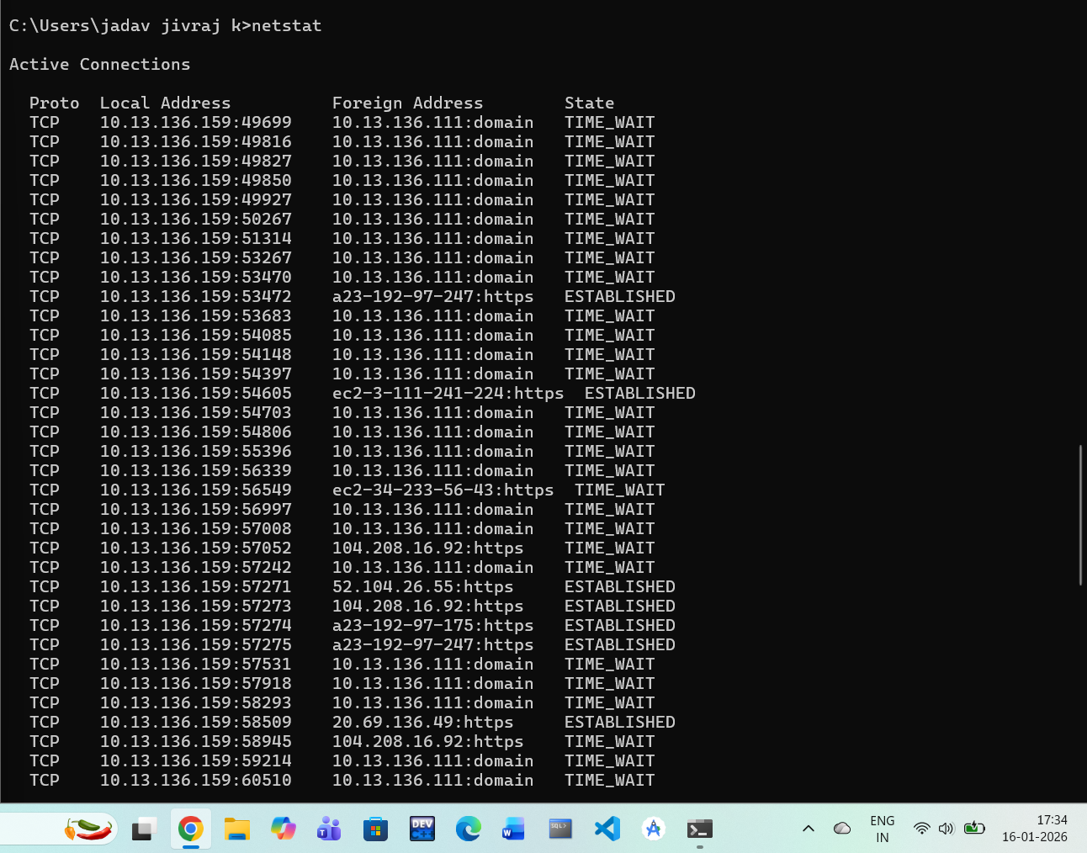

- nslookup :-

- nslookup is a command-line tool used to query DNS servers for domain name information.
- It helps find IP addresses, domain records, and DNS server details.
- The nslookup command is commonly used to troubleshoot DNS and name resolution problems.

Example :-
Command :- nslookup facebook.com
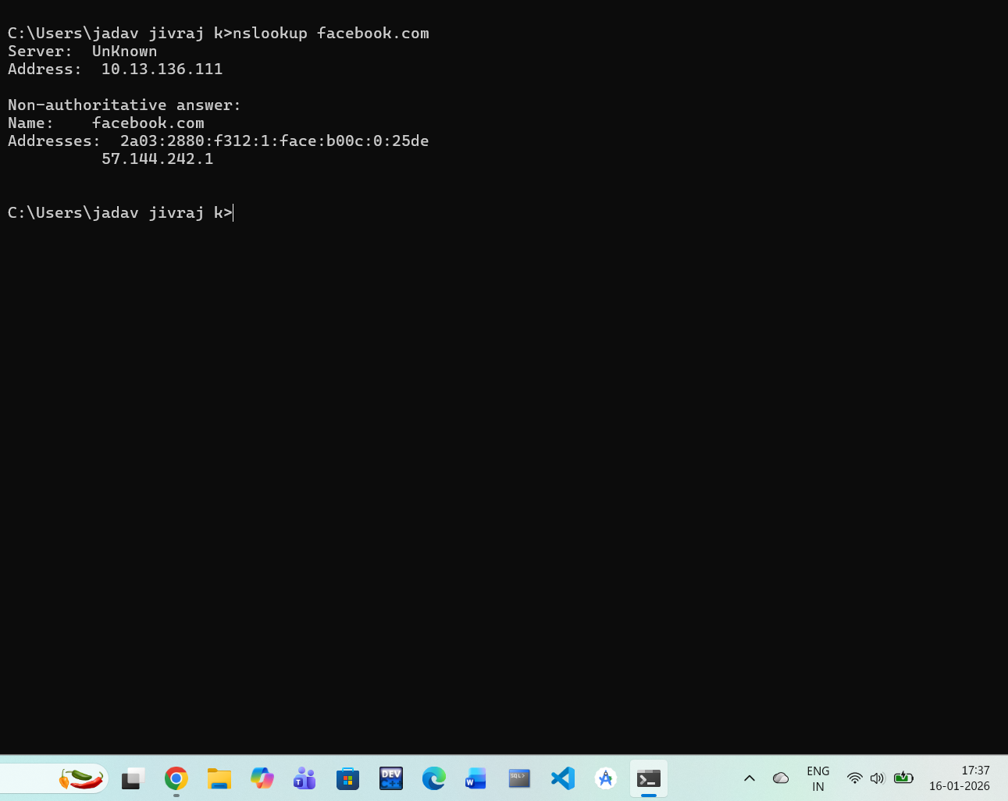

- ftp :-

- ftp (File Transfer Protocol) is a command used to transfer files between a client and a server over a network.
- It allows uploading and downloading of files using a command-line interface.
- The ftp command is easy to use but not secure, as data and passwords are sent without encryption.

Example :-

Command :- ftp test.rebex.net
